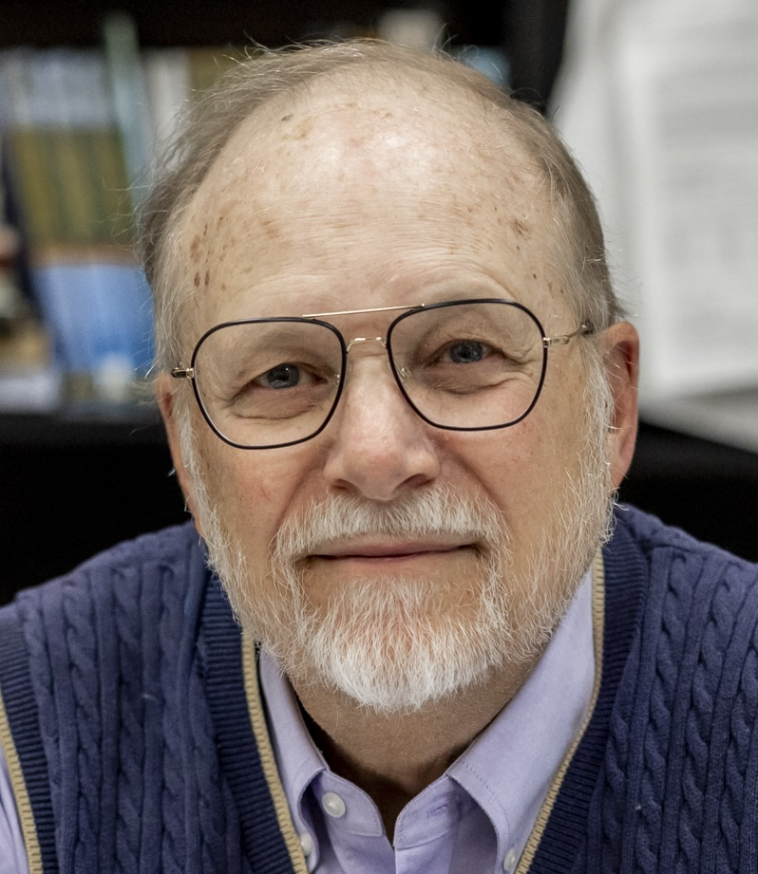
(High Resolution)

Title: A spatial forecast of some Mw≥6.5 earthquakes in California and Nevada

John E. Ebel
Weston Observatory, Boston College; ebel@bc.edu
Phone Number: +1 617 552 8319

Abstract:

This presentation is a prospective forecast of the locations of the next Mw≥6.5 earthquakes in California and Nevada based on the locations and rates of occurrence of M≥4.0 earthquakes during the past 30 years, called here preshocks. The time period of the forecast is arbitrarily set at 33 years. The forecast faults are the Anza section of the San Jacinto Fault, the Calaveras Fault, the creeping section of the San Andreas Fault, the Maacama Fault, the San Bernardino section of the San Jacinto Fault, and the southern San Andreas Fault, all strike-slip faults in California, and the normal-faulting Wassuk Range Fault in Nevada. The suspected preshocks have occurred randomly along the expected future fault ruptures at rates of at least 0.5 events per year. The temporal history of preshocks for past M≥6.5 earthquakes in California do not indicate when the future mainshock will occur. Outside of California, preshock activity was observed before the 2016 Mw7.0 Kumamoto, Japan earthquake, the 2023 Mw 7.8 Kahramanmaras, Turkey earthquake, and the 2017 Mw 6.5 Juizhaigou, China earthquake, all strike-slip events, as well as the 2008 Mw 7.9 Wenchuan, China thrust earthquake. The two mainshocks in China had preshock rates less than 0.5 events per year. By publishing this spatial earthquake forecast, seismologists in the future can evaluate whether or not this forecast was a total success, a total failure, or a partial success. The probability of just one of the forecast events actually taking place during the forecast time period is less than 2%.

Biography:

Prof. John E. Ebel obtained his AB (Physics) from Harvard University and his PhD (Geophysics) from the California Institute of Technology. He is a Professor Emeritus in the Department of Earth and Environmental Sciences at Boston College and a Senior Research Scientist at the Weston Observatory of Boston College. His research has focused on seismotectonics and seismic hazard in New England, California, Germany, and other parts of the world. He also has conducted research on earthquake statistics, forecasting and prediction, and he has published extensively on historical earthquakes.

Presenting author details
Full name: John E. Ebel, Ph.D.
Contact number: +1 617 552 8319
Twitter Acc:(none)
Session Theme: (Keynote)
Category: Oral presentation

